**ABSTRACT**

This project is applied for concept of Editing document & compilation of code. In this project, we have built a system that consist of an android app as well as website which performs several tasks related to Editor. The main objective of Smart Editor is to efficiently evaluate the candidate thoroughly through a fully automated system that not only saves lot of time but also gives fast results. Users can easily excess this site by creating an account or simply login through google and get the required information and can easily and effectively edit imaged document, run & compile code, be a part of virtual lab etc and these saves a lot of time. Scope of this project is very broad in terms of Editing & Compilation of code.

Few of them are: -

* This can be used to edit image by converting an image into document.
* Can be use to Compile & Run any code written in C, C++ & Java.
* Can be used anywhere any time as it is a web-based application.
* No restriction as user can simply login and can interact with us.
* Users can be a part of virtual lab.

**Chapter-1**

**OBJECTIVES & SCOPE OF THE PROJECT**

Smart Editor is a website in which many students simultaneously can use this application. In this, user can use any digital image which contain text and can use that image to convert it into the digital image which can be easily editable. User can have any type of image to begin with and can easily use this application as simple as clicking a button. This system is relates from the easy for the students and anyone who wants to use this application, for giving them a platform to edit there documents on the go, it is time saving process for the students and users.

Smart Editor Site has various features regarding with the basic functionalities of digitizing the documents. It includes features like Online Text Editor, Online Code Convertor. Further, He or She who is searching Jobs in MNC this score which have got in this test, help for getting job.

Now a day’s many students preparing for competitive exams that are prestigious and most important for quality based higher education. So a Site or web application is needed so that students don’t have to go to market and buy books but rather, they can simply login and can starts practicing questions that asked frequently in many competitive exams. This is setup to actually test knowledge and identity a person’s attribute to efficiently evaluate the candidate thoroughly through a fully automated system.

This Online Test Engine fires a series of objective type questions and stores the marks scored in the server. We have a pre settable time limit to answer the question about 90 seconds. At the end of this time limit, you will be taken to the next question without awarding any mark. The question need to be of the objective type and can have 2 or 4 options. It is essential that the user clicks at one option as otherwise the script will present the same question again. It calculates the score and the total marks scored at any point of time will always be visible at the top.

This can be used in any educational institutions as well as in corporate world. Can be used anywhere any time as it is a web based application (user Location doesn’t matter). No restrictions that user has to be present at a certain location.

Few days ago my Teacher discuss with me that he wants a website or more a web application that provides students notes and most important questions so that they can easily understand what questions actually being asked in prestigious competitive exams like CAT,GATE,XAT etc. So I have decided to work on this project so that it will helpful to all the students that are preparing for competitive exams.

I am using php with WordPress technology for taking test in efficient manner and no time is wasting for checking the paper.

PHP is a server-side scripting language designed for web development but also used as a general-purpose programming language. PHP stands for Hypertext Preprocessor. PHP code is interpreted by a web server with a PHP processor module, which generates the resulting web page: PHP commands can be embedded directly into an HTML source document rather than calling an external file to process data.WordPress is web software you can use to create a beautiful website or blog.WordPress is both free and priceless at the same time.The core software is built by hundreds of community volunteers, and when you’re ready for more there are thousands of plugins and themes available to transform your site into almost anything you can imagine.

**Chapter-2**

**THEORETICAL BACKGROUND**

**Online quizzes** are a popular form of entertainment for web surfers. Online quizzes are generally free to play and for entertainment purposes only though some online quiz websites offer prizes. Websites feature online quizzes on many subjects. One popular type of online quiz is a personality quiz or relationship quiz which is similar to what can be found in many women's or teen magazines. Websites hosting quizzes include Quizilla, FunTrivia, and OkCupid.Blog quizzes (also known as quiz blog) refer to a specific genre of quizzes which are conducted by the quizzers on blogs. Blog quizzes may be about verbs or a wide range of other topics.Many online quizzes are set up to actually test knowledge or identify a person's attributes. Some companies use online quizzes as an efficient way of testing a potential hire's knowledge without that candidate needing to travel. Online dating services often use personality quizzes to find a match between similar members. Quizot is a quizzing platform which allows users to take a quiz on a number of topics. Users can also contribute questions which are undertaken review before being published. Quizot mostly carries question content relevant to Quiz bowl, pub quizzing and quizzing in India. Each question has an associated time limit and answering correctly earns credits for the user as does contributing a question.Quiz as a form of knowledge transfer shows German Sixbreak. It is a free, web-based, collaborative quiz and works similar to Wikipedia. Anyone can contribute questions in conjunction with a reliable source. All questions are editable by quiz community.

A quiz is a form of game or mind sport in which the players (as individuals or in teams) attempt to answer questions correctly. In some countries, a quiz is also a brief assessment used in education and similar fields to measure growth in knowledge, abilities, and/or skills.Quizzes are usually scored in points and many quizzes are designed to determine a winner from a group of participants - usually the participant with the highest score.In an educational context, a quiz is usually a form of a student assessment, but often has fewer questions of lesser difficulty and requires less time for completion than a test. This use is typically found in the US, Canada, and some colleges in India. For instance, in a mathematics classroom, a quiz may check comprehension of a type of mathematical exercise.Additionally, a personality quiz may be a series of multiple-choice questions about the respondent without right or wrong answers. The responses to these questions are tallied according to a key, and the result purports to reveal some quality of the respondent. This kind of "quiz" was originally popularized by women's magazines such as Cosmopolitan. They have since become common on the Internet, where the result

page typically includes code which can be added to a blog entry to publicize the result. These postings are common on LiveJournal.There are also many online quizzes. Many webmasters have quiz sections on their websites and forums; for instance, phpBB2 has one MOD (modification) which allows users to submit quizzes, called the Ultimate Quiz MOD. The results of online quizzes are generally to be taken lightly, as they do not often reflect the true personality or relationship. They are also rarely psychometrically valid. However, they may occasion reflection on the subject of the quiz and provide a springboard for a person to explore his or her emotions, beliefs, or actions.

**Chapter- 3**

**DEFINATION OF PROBLEM**

The first problem is that there are loads of hard copied documents being generated. This brings us to the age-old discussion of keeping information in the form databases versus keeping the same on sheets of paper. Keeping the information in the form of hard-copied documents leads to the following problems:

**Lack of space** – It becomes a problem in itself to find space to keep the sheets of paper being generated as a result of the ongoing discussion. The documents being generated are too important to be ill-treated.

**Filing poses a problem** – Filing the documents categorically is a timeconsuming and tedious exercise.

**Filtering is not easy** – It becomes hard to filter relevant documents for the irrelevant ones if the count of the same crosses a certain manageable number.

**Reviewing becomes time-consuming** –All the process done manually at the centers and all

the records are maintained on the papers. So the maintenance of the record is very difficult in the departments and as well as it’s very difficult for the workers to check the record. The Existing system is paper based, time consuming, monotonous, less flexible and provides a very hectic working schedule. The chance of loss of records is high and also record searching is difficult. Maintenance of the system is also very difficult and takes lot of time.

Result Processing is slow due to paper work and requirement of staff.

To solve these problems they required a computerized system to handle all theworks. They required a web based application that will provide a working environment that will be flexible and will provide ease of work and will reduce the time for report generation and other paper works. Some Common attributes are:

* **Usability:** The links are provided for each form. The user is facilitated to view and make entries in the forms. Validations are provided in each field to avoid inconsistent or invalid entry in the databases. Some forms consists Hyper Links, which provides further details. Reports screen contains text boxes

and drop down lists, so that reports can be produced. Application will allow only valid users to access the system.

* **Security:** Access to any application resource will depend upon user’s designation. There are two types of users namely Administrator and Student. Security is based upon the individual user ID and Password.
* **Maintainability:**The installation and operation manual of examination management system will be provided to the user**.**
* **Availability:** System will be available around the clock except for the time required for the backup of data.
* **Portability:** The application is developed in PHP WordPress. This site is portable to Google Chrome Browser i.e. site is best viewed with Google Chrome. But it can also work with other browsers like Internet Explorer, Mozilla Firefox etc.

This Web Application provides facility to conduct online examination worldwide.It saves time as it allows number of students to give the exam at a time and displays the results as the test gets over, so no need towait for the result. It is automatically generated by the server. Administrator has a privilege to create, modify and delete the test papers and its particular questions. User can register, login and give the test with his specific id, and can see the results as well. User interface is only in English i.e. no other language option is available.

User can login only with his assigned username and password i.e. no guest facility is available. Limited to HTTP/HTTPS. But User can access complete site only he/she take proper membership for that. Four types of memberships are available:

* **Annual @ $16.00:** That allows user to access site completely for 12 months i.e. 1 year complete but after payment of $16.00.
* **6 Months @ $14.00:** That allows user to access site completely for 6 months complete but after payment of $14.00.
* **3 Months @ $10.00:** That allows user to access site completely for 3 months complete but after payment of $10.00.**45 Days @ $6.50:** That allows user to access site completely for 45 days complete but after payment of $6.50.

**Chapter-4**

**SYSTEM REQIREMENT SPECIFICATION**

**4.1 INTRODUCTION**

**4.0.1 PURPOSE**

The purpose of this document is to outline the operational requirements to my website in order to make it more attractive, efficient & user-friendly. The purpose of this document is to present a detailed description of the Smart Editor. It will explain the purpose and features of the system, the interfaces of the system, what the system will do, the constraints under which it must operate and how the system will react to external stimuli. This document is intended for both the stakeholders and the developers of the system.

**4.0.2 SCOPE OF PROJECT**

This software system will be a Smart Editor System for anyone who wants to use this system for their needs. This system will be designed to maximize the user work by providing them the facilities to get maximum productivity of their work. By maximizing the work efficiency and production the system will meet the user’s needs while remaining easy to understand and use.

More specifically, this system is designed to allow a user to manage his or her work efficiently and easily. Well formed algorithms are used for performing the work of user and to provide better platform for digitizing their documents and using them according to their needs.

**4.1 INTENDED AUDIENCE:**

**4.1.1. TESTERS:** The testers would use this document to know the interface website.

**4.2 DEFINITIONS, ACRONYMS, AND ABBREVIATIONS**

**SRS** – Systems Requirements Software, this document which outlines the requirements that the software must fulfil. Entirely design independent.

**User** – any person who uses the website and access its content.

**Member** – any person who uses the website and access its content but after taking membership.

**Administrator** – a person who has administrative access to the advanced settings.

**RDBMS**: Relational Database Management Systems

**MNC**: Multi National Companies

**UML**: Unified Modelling Language

**ER**: Entity Relationship

**4.3 REFERENCES**

IEEE. *IEEE Std 830-1998 IEEE Recommended Practice for Software Requirements Specifications.* IEEE Computer Society, 1998.

**4.4 OVERVIEW**

The next chapter, the Overall Description section, of this document gives an overview of the functionality of the product. It describes the informal requirements and is used to establish a context for the technical requirements specification in the next chapter.

The third chapter, Requirements Specification section, of this document is written primarily for the developers and describes in technical terms the details of the functionality of the product.

Both sections of the document describe the same software product in its entirety, but are intended for different audiences and thus use different language.

**4.5 OVERALL DESCRIPTION**

**4.5.1 PRODUCT PERSPECTIVE**

This product is designed in order to provide easy way to prepare for various exams and provide much better ways to practice and builds up one’s concept in its interested field. This product will work online with proper internet connection so independent over other products of the system.

**4.5.2 PRODUCT FUNCTIONALITY**

This product or site provides various types of questions belongs to different categories of exams that now a day’s very crucial for making bright carrier. These questions can help user to prepare for different type of exams and build concepts crystal clear. Here user can prepare according to his/her performance by analyzing performance graph test wise. Marks will be given according to each test and certificate will also be provided if he/she scores best provided he/she has to apply for membership specified in the site.

**4.5.3 USER CHARACTERISTICS**

There is no any specific characteristics required but user should know how to operate internet and how to make online payments through PayPal or I should say user should have PayPal account in order to take membership and should enable background colors or images while printing certificate

**4.5.4 OPERATING ENVIRONMENT**

The operating environment of this project used some software and operating system .The Online Quiz Site project is being developed in php WordPress technology so the software, hardware and operating system used are:-

**4.5.4.1 OPERATING SYSTEM-**

Windows XP/Vista/7/8

Linux, Ubantu,

MacOs

**4.5.4.2 SOFTWARE REQUIREMENT-**

**Dreamweaver:** Adobe Dreamweaver (formerly Macromedia Dreamweaver) is a proprietary web development application originally created by Macromedia, and is now developed by Adobe Systems, which acquired Macromedia in 2005. Dreamweaver is available for both Mac and Windows operating systems. Recent versions have incorporated support for web technologies such as CSS, JavaScript, and various server-side scripting languages and frameworks including ASP (ASP JavaScript, ASP VBScript, ASP.NET C#, and ASP.NET VB), ColdFusion, Script let, and PHP.

**Xampp Server: It** is a web server which used for php, pearl, apache server and for mysql.

**4.5.4.3. HARDWARE REQUIREMENT-**

**RAM: -** 1 GB (recommended)

**HDD: -** 40 GB (recommended)

**Processor: -**P4 (or any other higher configuration)

**Internet: -** Independent LAN/WAN for the company.

**4.5.5 DESIGN AND IMPLEMENTATION CONSTRAINTS**

For designing and implementing this project there we use different –different programming languages and editors which are:-

**4.5.5.1. MY SQL:** -

SQL is used for storing data as a Back End and it is compatible also for web applications and is also provide its default web server for database.

**4.5.5.2. JAVA SCRIPT**:

JavaScript is a prototype-based scripting language that is dynamic, weakly typed and has first-class functions. It is a multi-paradigm language, supporting object-oriented, imperative, and functional programming styles.

**4.5.5.3. PHP:**

PHP is a widely-used open source general-purpose scripting language that is especially suited for web development and can be embedded into HTML. PHP is a server-side scripting language, like ASP. PHP scripts are executed on the server PHP supports many databases (My SQL, Informix, Oracle, Sybase, Solid, Posture SQL, Generic ODBC, etc.) PHP is open source software. PHP is free to download and use.

**4.5.5.4. HTML:**

Hyper Text Markup Language is the predominant markup language for web pages. It provides a means to describe the structure of text-based information in a document and to supplement that text with interactive forms, embedded images, and other objects.

**4.5.5.5. WordPress: -**

WordPress is web software you can use to create a beautiful website or blog. WordPress is both free and priceless at the same time. The core software is built by hundreds of community volunteers, and when you’re ready for more there are thousands of plugins and themes available to transform your site into almost anything you can imagine.

**4.5.6 USER DOCUMENTATION**

The Online Quiz Site is user interactive and easy for use for the citizens/user. A user document should be provided at the end of the development.

**4.5.7 ASSUMPTIONS AND DEPENDENCIES**

This website will response to your queries within the given time limitation and as per the government criteria

**4.6 EXTERNAL INTERFACE REQUIREMENTS**

**4.6.1 USER INTERFACES**

Here user interfaces are provided by certain options like:

* Text Editor
* Code Convertor
* Virtual Lab

**4.6.2 HARDWARE INTERFACES**

Hardware Interfaces are provided by:

* Keyboard
* Mouse
* Monitor
* Speakers

**4.6.3 SOFTWARE INTERFACES**

Software Interfaces are provided by:

* XAMPP
* Dreamweaver CS 6

**4.6.4 COMMUNICATION INTERFACES**

At the transmission and network layers, the Transmission Control Protocol (TCP and the Internet Protocol (IPv4) will be utilized in the web-based portion of this product.

**4.7 FUNCTIONAL REQUIREMENTS**

**4.7.1 DEMO TEST**

4.7.1.1 Introduction: Demo Test is the short introduction of our online quiz site where it is shown how test will be taken; marks will be provided so that users come to know about website way of working.

4.7.1.2 Inputs: Mouse and Keyboard

4.7.1.3 Processing: After providing username and password, user can click on “Take Demo Test” link where he/she will be redirected on demo test.

4.7.1.4 Outputs: Users can start test, after completing demo test he can see marks scored.

**4.7.2 VIDEOS**

4.7.2.1 Introduction: Different Videos on different categories of subjects and on different categories of topics will be provided where user can learn some stuffs that helps him to give test conceptually and correctly.

4.7.2.2 Inputs: Mouse and Keyboard

4.7.2.3 Processing: When user click on particular video then that video starts. 4.7.2.4 Outputs: Video starts from where user can learn something and a full screen mode is also provided where user can switch to full screen mode.

**4.7.3 QUESTIONS AND ANSWERS**

4.7.3.1 Introduction: It is user help desk section where user can ask questions and answer will be provided by admin so that if user has doubt in any of the topic then our team can solve all doubts of user so that user can learn in much efficient manner.

4.7.3.2 Inputs: Mouse and Keyboard

4.7.3.3 Processing: When user click on Ask Question then user will be redirected to Ask Questions Page. If he wants to see answers of his question from different users then he will be redirected to Single Question Page where he can see answers from our experienced team members and also from other users.

4.7.3.4 Outputs: User can ask questions on Ask Questions Page with complete description of question along with title of question.

**4.8 USE CASES**

**4.8.1 Digitize document**

|  |
| --- |
|  |
|  | C:\Users\Admin\AppData\Local\Temp\ksohtml\wpsB8B.tmp.png |

**Fig 4.1Brief Description**

The User accesses the Smart Editor, uploads a image or document and fetch the text from it and digitizes the image or document.

**Initial Step-By-Step Description**

Before this use case can be initiated, the User has already accessed the Smart Editor System Website.

1. The User chooses to upload an image or “.pdf” file.
2. The system displays the fetched text to the user.
3. The system presents the abstract text of the doc or image to the reader.
4. The User chooses to download the digitized file.

**Xref:** Section 3.2.1, Search Article

**4.8.2 N0TES MAKING**

|  |
| --- |
|  |
|  | C:\Users\Admin\AppData\Local\Temp\ksohtml\wpsEC78.tmp.png |

**Fig 4.2**

**Brief Description**

The user can create the notes by using these features according to their needs.

**Initial Step-By-Step Description**

Before this use case can be initiated, the User has already connected to the Smart Editor System Website.

1. The User chooses the *Notes making button*.
2. The System uses the *digitize document* and store the data in notes format.

**Xref:** Section 3.2.2, Communicate

**4.8.3 CODE CONVERTOR**



**Fig 4.3**

**Brief Description**

The user submits a pdf or image of an code.

**Initial Step-By-Step Description**

Before this use case can be initiated, the User has already connected to the Smart Editor System.

1. The Reviewer chooses the *Code convertor* button.
2. The System uses the *digitize document* and fetch out the code from that image or pdf.
3. User can download the generated text file.

**Xref:** Section 3.2.2, Communicate

**4.8.4 USER ASKS QUESTIONS**



**Fig 4.4**

**Brief Description**

Here user after login can ask questions whose answer will be submitted by admin or others users can also submit their answers.

**4.8.5 USER GETTING ANSWERS**



**Fig 4.5**

**Brief Description**

Here user can see answer to his question from admin (editor) or other users can also submit their reviews to it and answer will be enlisted according to decreasing number of votes i.e. answer with maximum votes is shown first.

**4.8.6 EDITOR SUBMIT ANSWER**



**Fig 4.6**

**Brief Description**

Here editor submit answer to user question. Editor is our experienced teacher’s team that answer user’s question conceptually.

**4.8.7 EDITOR REMOVE QUESTION**



**Fig 4.7**

**Brief Description**

Here editor can remove user question if it is not required any more.

**4.9 NON-FUNCTIONAL REQUIREMENTS**

**4.9.1 PERFORMANCE**

Site performance is quite good but it may work slower depends on internet connectivity speed i.e. 80% of work will be processed in seconds though JavaScript may not be properly worked as it may require high speed connection to download.

**4.9.2 RELIABILITY**

Here user has reliable transactions over PayPal but provided he/she should have PayPal account and site is also reliable as username for each user will be unique so each user will be uniquely identified.

**4.9.3 AVAILABILITY**

Here user feedback will be considered and reply also will be provided to user. So that user feels comfortable from services provided by us. Our services of videos, questions and answer and query section will always available to user so user can take maximum benefit from it.

**4.9.4 SECURITY**

High security is provided to user in terms of transactions or user account or in any of the functional requirement. Here user will have secured transactions as well as if we say about query section then here user can also put question that can be private to his/her account i.e. the question will not be shown

publically and will only answered by editor. The system will also check validity of Registration ID whether user has valid Registration ID or not

**4.9.5 MAINTAINABILITY**

Here site will be maintained by Admin and editors. All editors will be given restrictions to certain section like user account details. Some editors will be given restrictions like removal of user asked questions or some editors will be given restrictions to edit video section etc.

**4.9.6 PORTABILITY**

This site is portable to Google Chrome Browser i.e. site is best viewed with Google Chrome. But it can also work with other browsers like Internet Explorer, Mozilla Firefox etc.

**4.10 INVERSE REQUIREMENTS**

User should have high protected password in order to maintain security on both site as well as on his/her PayPal account. He should not apply for any membership before confirmation or complete satisfaction as membership can’t be cancelled.

**4.11 DESIGN CONSTRAINTS**

Since this site is based on free themes provided by WordPress so it footer may contains advertisement. As previously stated, username is not shown after login as site is based on plugin and plugin doesn’t provide such facility of showing username. Though manually we can do it but it may not support design of the site.

**4.12 LOGICAL DATABASE REQUIREMENTS**

**DATA FORMAT :**Data about complete site i.e. user registrations, test questions, number of tests given, marks stored in each test is stored. For each user account, the login ID, name, password, email address, username will be stored in database. The email address gives the user option in order to receive any updates of asking questions or membership confirmation etc. In Test Questions table we have attributes like id, set, subset, opt1, opt2, opt3, opt4, and answer column is provided. There are many other tables that belong to post, subscription levels, and subscription transactions. In post table we have other attributes like author, date of post, contents, title all are of textual formats. In subscription levels table, we have various attributes like sub id, level id, level period, level price etc. In subscription transactions table, we have attributes like transaction id, payment id, user id, sub id, payment type, total amount, transaction expiration etc.

**ACCESSIBILITY AND SECURITY**

Only admin has authority to edit any section but admin can give authority to editor also in order to provide or change test questions.

**Chapter-5**

**SYSTEM PLANNING**

Planning the system requires the user to define what the problem is. The planning may also include how the user would like to solve the problem. Defining the scope of the problem is also important in this stage as well. Defining the scope helps to prevent the project from scope once the problem is determined, and one or more solutions have been selected, planning to implement the solution begins. Multiple scenarios may be enacted to determine the best course of action for implementing the system.

Course of action should be well documented and take into consideration a schedule showing anticipated start and completion times of activities (milestones) leading to the objectives, knowing expenditures required to achieve objectives, scheduling regular status reviews (are we on course?), anticipating any organizational restructuring to accommodate the objectives, anticipating and planning for mitigation of risks that may hinder achievements, implementing policies and procedures for decision making, and defining a standard level of performance.

Within the planning according to the John Sazinger "five of the main activities must exist" as he explain in his book the fives activities should include:

* + - * Define the problem
      * Produce the project schedule
      * Confirm project feasibility
      * Staff the project
      * Launch the project

Why do plans fail? Some of the many reasons are:

* + - * Goals/specifications are not understood.
      * Objectives are too expensive for the time allotted.
      * Budgets were not accurate.
      * Project is understaffed or under skilled.
      * Status reviews were not scheduled or insufficient.
      * Poor morale (no commitment).

One of the most difficult decisions in planning is to know when to pull the plug on a project. This will require an effective control and monitoring system. If you cannot monitor a system you cannot control it. No organization wants to admit failure but there may come a point when a project can no longer be salvaged. This is especially critical with Information Technology projects because of rapidly changing technologies. Most managers are reluctant to prematurely terminate a project as careers and egos are at stake. The fallacy of sunk costs may play a role as well. The result is that projects continue beyond the point of no return. To avoid this problem, monitor and control systems must be put in place early during the planning stage. It is critical to define and enforce milestones where a project will be terminated if necessary. A saving grace is that because a project is terminated it doesn't make it a complete failure. Excessive cost are saved for the organization and management can walk away with lessons learned that can be applied to the next project. In general there are two types of monitoring "INFORMAL" and "FORMAL". Informal are typically general meetings, email, and observing. The formal include status reports, scheduled milestones, audits, reviews, and generally more costly and are used during system development processes. Both systems can be used in combination and involve the questions: "what performance metrics to use" and "how often do reviews occur"? Attention and energy must be focused on identifying and correcting out-of-control processes.

**PERT CHART**

A PERT chart is a project management tool used to schedule, organize, and coordinate tasks within a project. PERT stands for Program Evaluation Review Technique, a methodology developed by the U.S. Navy in the 1950s to manage the Polaris submarine missile program. A similar methodology, the Critical Path Method (CPM) was developed for project management in the private sector at about the same time.

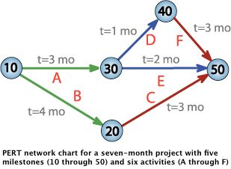

**Fig 5.1**

**Chapter-6**

**DETAILED LIFE CYCLE OF THE PROJECT**

SDLC refers to a methodology for developing systems. It provides a consistent framework of tasks and deliverables needed to develop systems. The SDLC methodology may be condensed to include only those activities appropriate for a particular project, whether the system is automated or manual, whether it is a new system, or an enhancement to existing systems. The SDLC methodology tracks a project from an idea developed by the user, through a feasibility study, systems analysis and design, programming, pilot testing, implementation, and post-implementation analysis. Documentation developed during the project development is used in the future when the system is reassessed for its continuation, modification, or deletion.

**SDLC Phases**

Phases in SDLC are Planning, Analysis, Design, Implementation, Testing and Maintenance.SDLC is a guideline for developing systems/software that involves following Phases:

1. Project planning, feasibility study: Establishes a high-level view of the intended project and determines its goals.
2. Systems Analysis, Requirements Definition: Refines project goals into defined functions and operation of the intended application. Analyzes end-user information needs.
3. Systems Design: Describes desired features and operations in detail, including screen layouts, business rules, process diagrams, pseudo

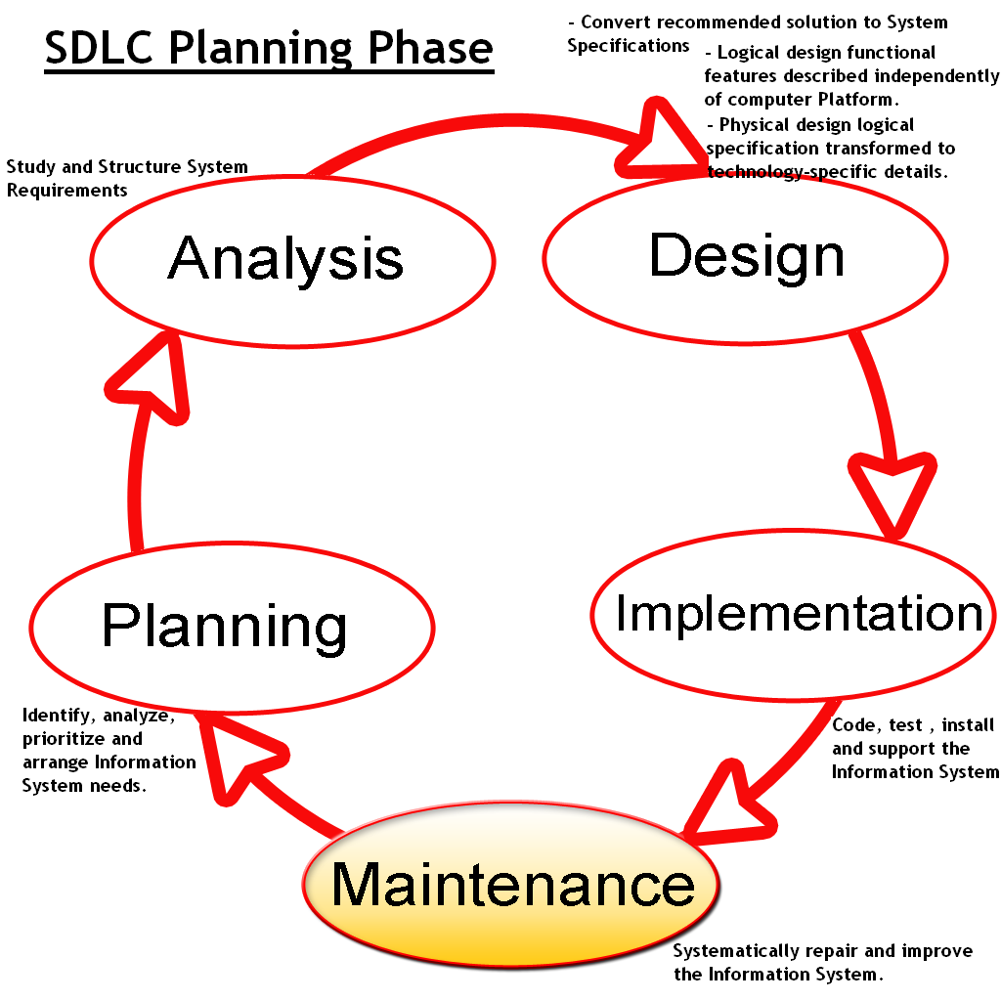

**Fig 6.1**

1. Code and other documentation. A prototype should be developed during the logical design phase if possible. The detailed design phase modifies the logical design and produces a final detailed design, which includes technology choices, specifies system architecture, meets all system goals for performance, and still has all of the application functionality and behavior specified in the logical design.
2. Implementation (Development): The real code is written here.
3. Integration and Testing: Brings all the pieces together into a special testing environment, then checks for errors, bugs and interoperability.
4. Acceptance, Installation, Deployment: The final stage of initial development, where the software is put into production and runs actual business.
5. Maintenance: What happens during the rest of the software's life: changes, correction, additions, moves to a different computing platform and more.



**Fig 6.2**

**Chapter-7**

**UML MODELING**

**UNIFIED MODELING LANGUAGE** (**UML**) is a standardized general-purpose modelling language in the field of object oriented software engineering The Unified Modeling Language includes a set of graphic notation techniques to create visual model of object-oriented software-intensive systems.

Unified Modelling Language is used to specify, visualize, modify, construct and document the artifacts of an object-oriented software-intensive system under development. The met modeling architecture of Unified Modeling Language (UML) is defined in the Meta object function (MOF). Modeling.

It is important to distinguish between the UML model and the set of diagrams of a system. A diagram is a partial graphic representation of a system's model. The model also contains documentation that drives the model elements and diagrams (such as written use cases).

**UML diagrams represent two different views of a system model**

* Static (or structural) view: emphasizes the static structure of the system using objects, attributes, operations and relationships. The structural view includes class diagrams and composite structure diagrams.
* Dynamic (or behavioral) view: emphasizes the dynamic behavior of the system by showing collaborations among objects and changes to the internal states of objects. This view includes sequence diagrams, activity diagrams and state machine diagrams.

**DIFFERENT DAIGRAMS**

**7.1 USE CASE DIAGRAM:**

**Use case diagrams** are usually referred to as behavior diagrams used to describe a set of actions that some system or systems (subject) should or can perform in collaboration with one or more **external users** of the system each use case should provide some observable and valuable result to the actors or other stakeholders of the system.

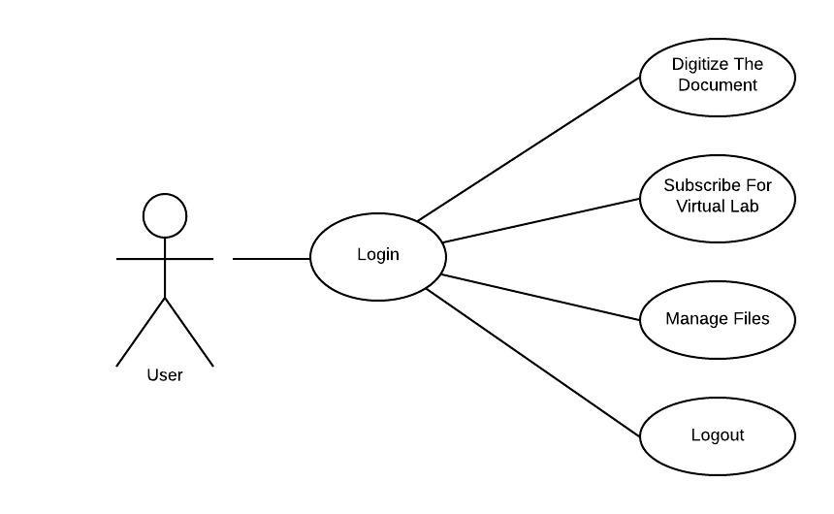

**Fig 7.1 Use Case for Smart Editor**

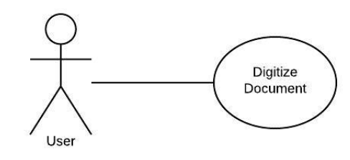

**Fig 7.2 -Use Case for Digitize Document**

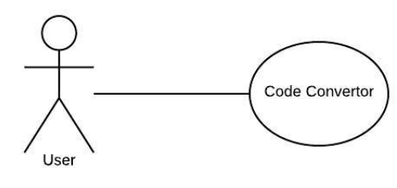

**Fig 7.3 - Use Case for Code Convertor**

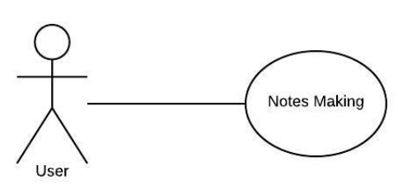

**Fig 7.4 - Use Case for Notes Making**

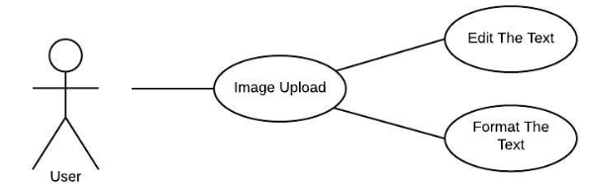

**Fig 7.5 - Use Case for Text Editor(Detailed)**

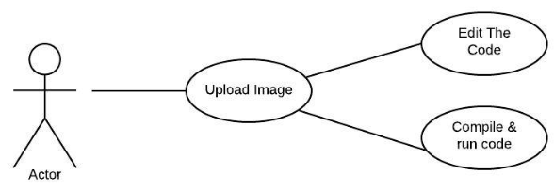

**Fig 2.6 - Use Case for Code Convertor (Detailed)**

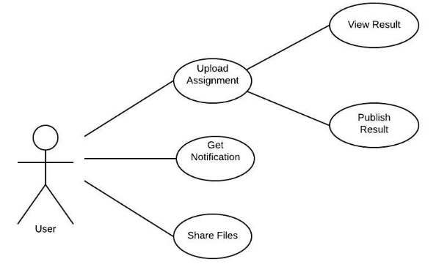

**Fig 7.7 - Use Case for Virtual Lab – Questionnaire**

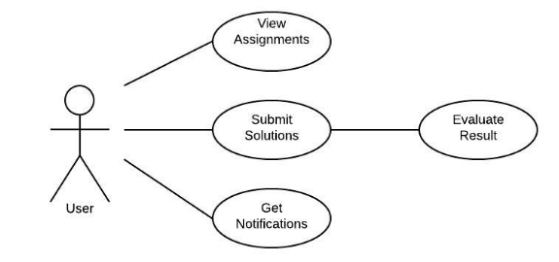

**Fig 2.8 - Use Case for Virtual Lab - User**

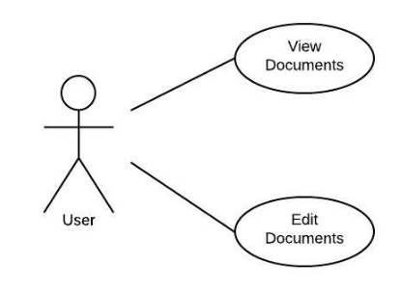

**Fig 7.9 - Use Case for File Management**

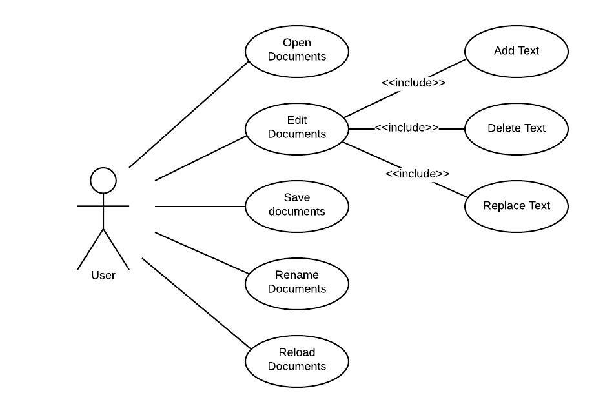

**Fig 7.10 - Use Case for Complete Representation of Smart editor**

**7.2 CLASS DIAGRAM:**

The class diagram is the main building block of object-oriented modeling. It is used both for general conceptual modeling of the systematic of the application, and for detailed modeling translating the models into programming code.

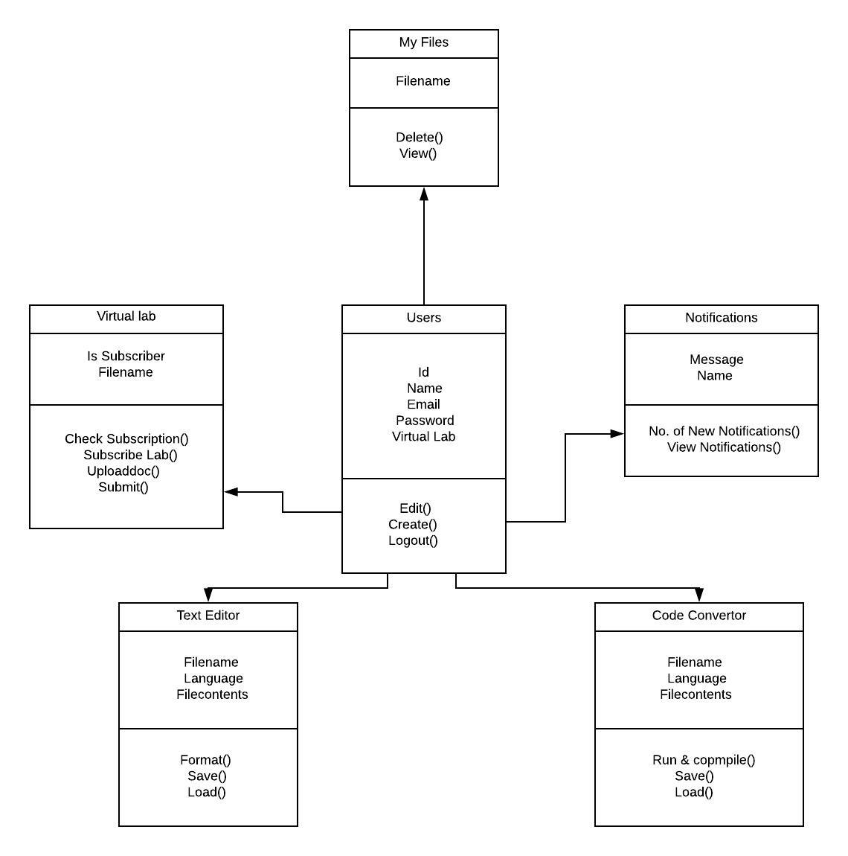

**Fig 7.2 – Class Diagram for Smart Editor**

**7.3 COLLABRATION DIAGRAM**

UML Collaboration diagrams (interaction diagrams) illustrate the relationship and interaction between software objects. They require use cases, system operation contracts, and domain model to already exist. The collaboration diagram illustrates messages being sent between classes and objects (instances). A diagram is created for each system operation that relates to the current development cycle (iteration).

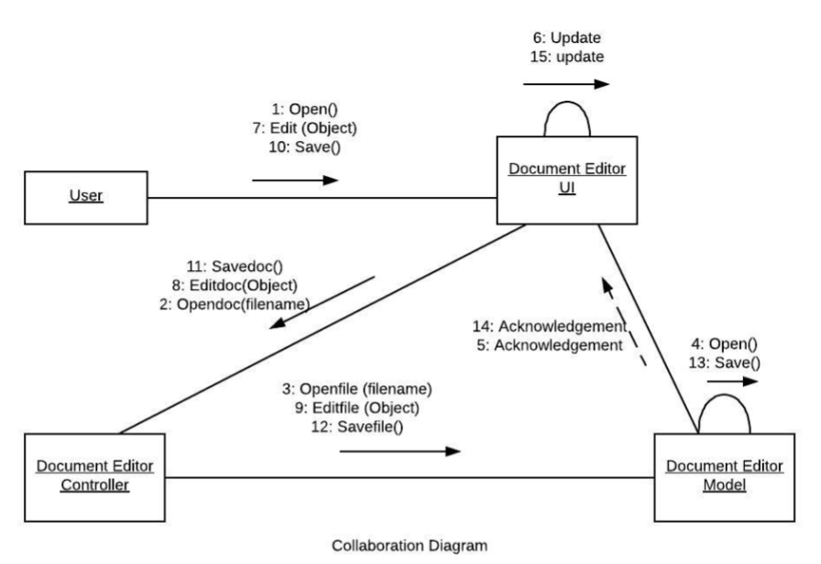

**Fig 7.3 – Collaboration Diagram for Smart Editor**

**7.4 SEQUENCE DIAGRAM:**

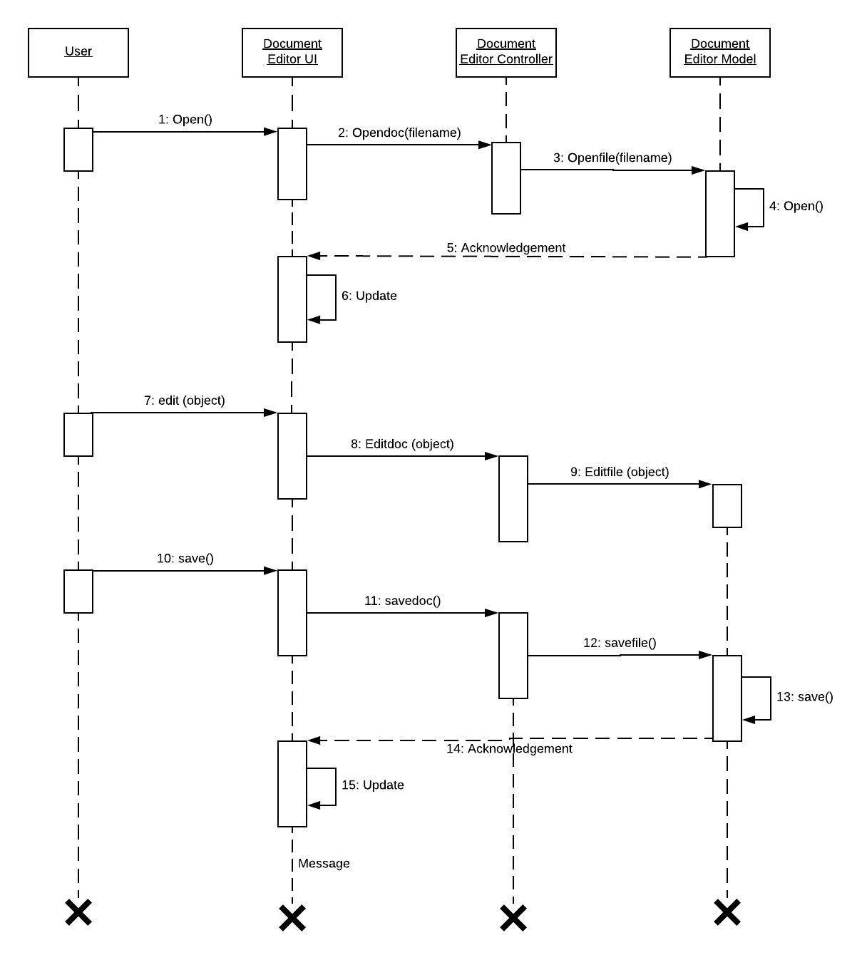

**Fig 7.4 – Sequence Diagram for Smart Editor**

**7.5 ACTIVITY DIAGRAM:**

Activity diagrams are graphical representations of workflows of stepwise activities and actions with support for choice, iteration and concurrency. In the Unified Modeling Language, activity diagrams can be used to describe the business and operational step-by-step workflows of components in a system. An activity diagram shows the overall flow of control. Activity diagrams are constructed from a limited number of shapes, connected with Arrows. The most important shape types:

* Rounded rectangles represent activities;
* Diamonds represent decisions;
* Bars represent the start (split) or end (join) of concurrent activities;
* A black circle represents the start (initial state)of the workflow;
* An encircled black circle represents the end (final state).

Arrows run from the start towards the end and represent the order in which activities happen. Hence they can be regarded as a form of flowchart. Typical flowchart techniques lack constructs for expressing concurrency. However, the join and split symbols in activity diagrams only resolve this for simple cases; the meaning of the model is not clear when they are arbitrarily combined with decisions or loops. Name of Activity: Ask for Login and registration. Description: User request for Login. Preconditions: Administrator is already logged in. Normal flow of events:

* The System user logged in.
* The system user is verified.

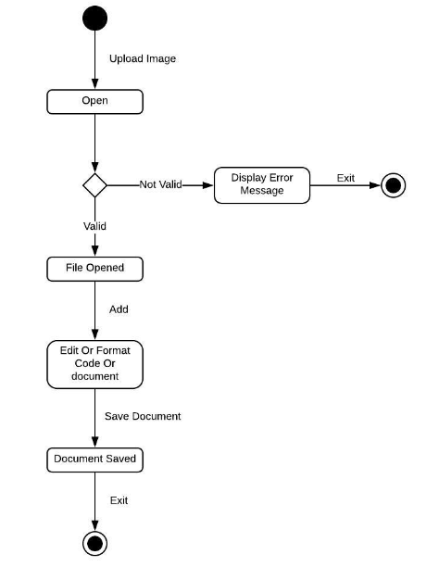

**Fig 8.1 – Activity Diagram for Smart Editor**

**7.6 STATECHART DIAGRAM:**

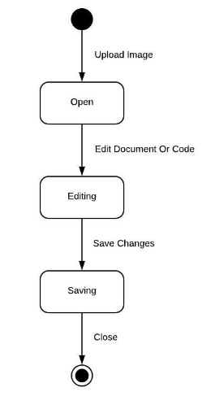

**Fig 7.1 – State Chart Diagram for Smart Editor**

**7.7 COMPONENT DIAGRAM:**

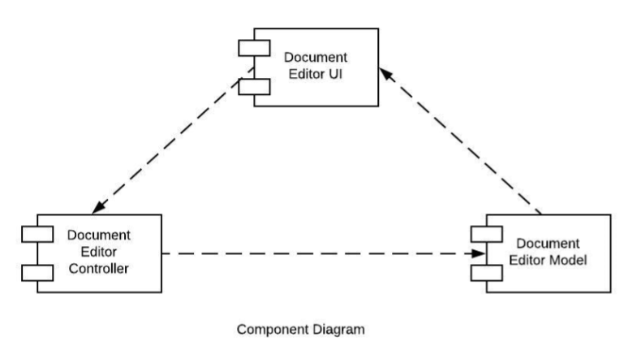

**Fig 9.1 – Component Diagram for Smart Editor**

**7.8 DEPLOYMENTDIAGRAM:**

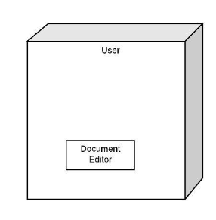

**Fig 11.1 – Deployment Diagram for Smart Editor**

**Chapter-8**

**DFD**

**DATA FLOW DIAGRAM**

The data flow diagram is a graphical representation that depicts information flow and the transforms that are applied as data moves from input to output. The DFD may be used to represent a system or software at any level of abstraction. In fact DFD may be partitioned into levels that represent increasing information flow and functional detail.

**SYMBOLS USED IN DFDS**

DFD consist of a series of symbols joined together by a line. There are may be a single DFD for entire system or it may be exploded into various levels, namely Lavel1, Lavel2, Lavel3 etc. The top-level diagram is often called a context diagram. Context diagram contains a single process and it shows an overall view of the system under development. Four symbols are used in drawing dataflow diagrams.

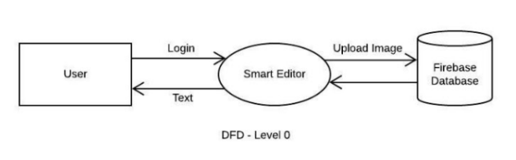

**Fig 5.1 –DFD level 0**

**8.3 FIRST LEVEL**

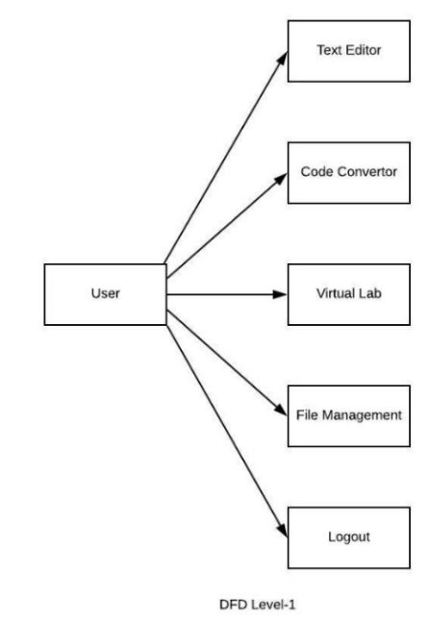

**Fig 5.2 – DFD level 1**

**8.5 SECOND LEVEL DIAGRAM**

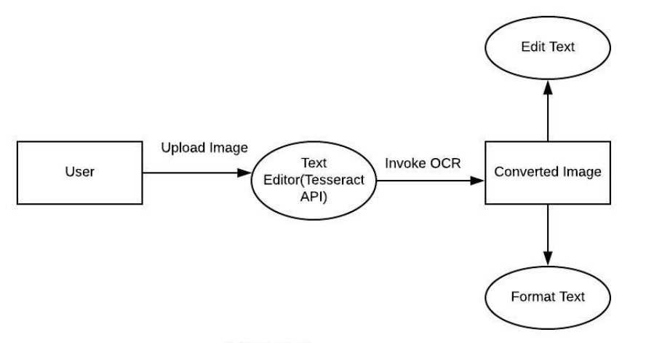

**Fig 5.3 – DFD level 2 for Text Editor**

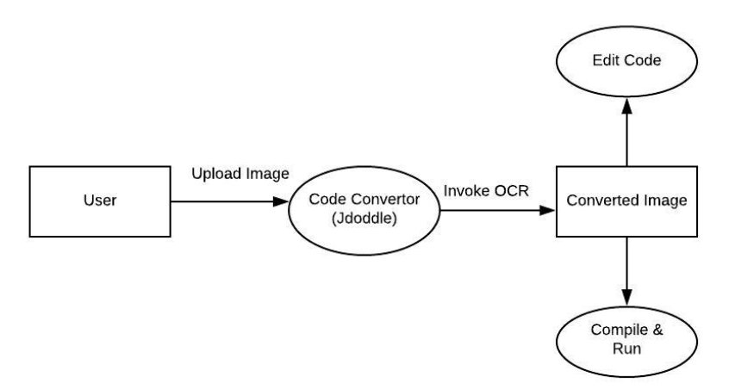

**Fig 5.4 – DFD level 2 for Code Convertor**

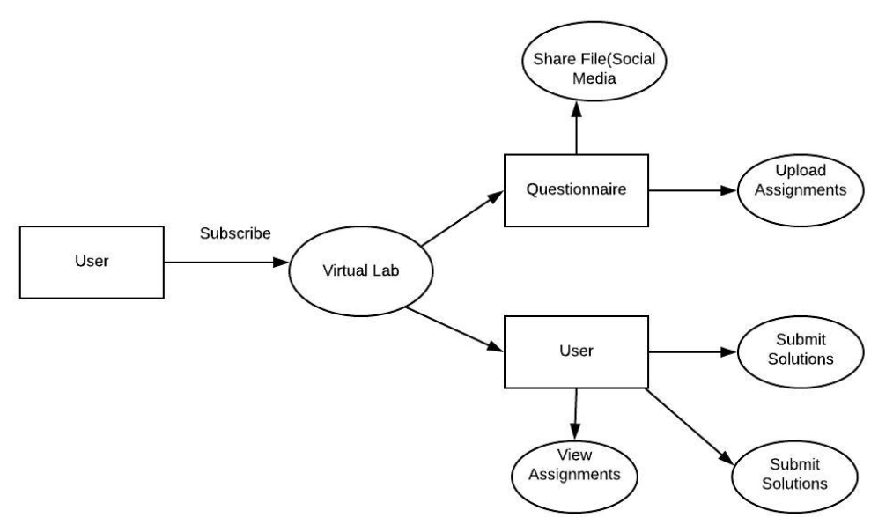

**Fig 5.5 – DFD level 2 for Virtual Lab**

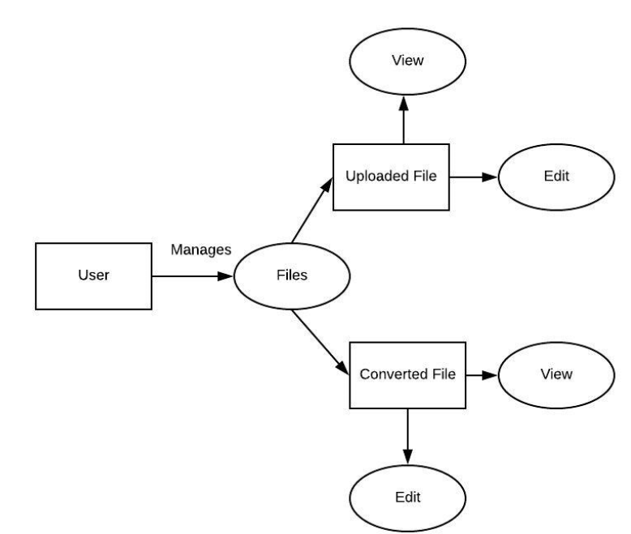

**Fig 5.6 – DFD level 2 for Management Files**

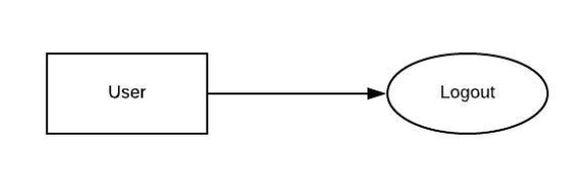

**Fig 5.7 – DFD level 2 for Management Files**

**Chapter-9**

**ER DIAGRAMS**

**Entity Relation Ship Modeling**

P.P. Chen introduced the E- R model. Entity – Relationship modeling is a details logical representation of the entities, associations and data elements for an organization or business area.

**Entities**

An Entity is a person, place, thing or event of interest to the organization and about which data are captured, stored or processed.

**Attributes**

Various types of data items that describe an entity are known as attributes.

**Relationship**

An association of several entities in a Entity-Relation model is called relationship.

**Entity Relationship Diagram**

The overall logical structure of a database can be expressed graphically by an entity relationship diagram.

**Name Symbol Meaning**

Rectangle Represents Entity set

Oval Represents Attribute

Diamond Represents relationship

among entity set

Line Sets and entity set to

relationship

**Three Types of relationship exist among entities:**

These are:

1. One- to-one

2. One-to-many

3. Many-to-Many

**One to One Relationship (1:1)**

A one to one (1:1) relationship is an associated only between two entities.

**One to much Relationship (1: M)**

A one to many (1: M) relationship exist when one entity is related to more entities.

**Many to many Relationship (M: M)**

A many to many (M: M) relationship describe entities may have many relationship among each other.

**9.1 ER DIAGRAM**

It is an abstract and conceptual representation of the data. Entity Relationship modeling is a Database Modeling Method, used to produce a types of conceptual schema.Entities: User, Administrator.

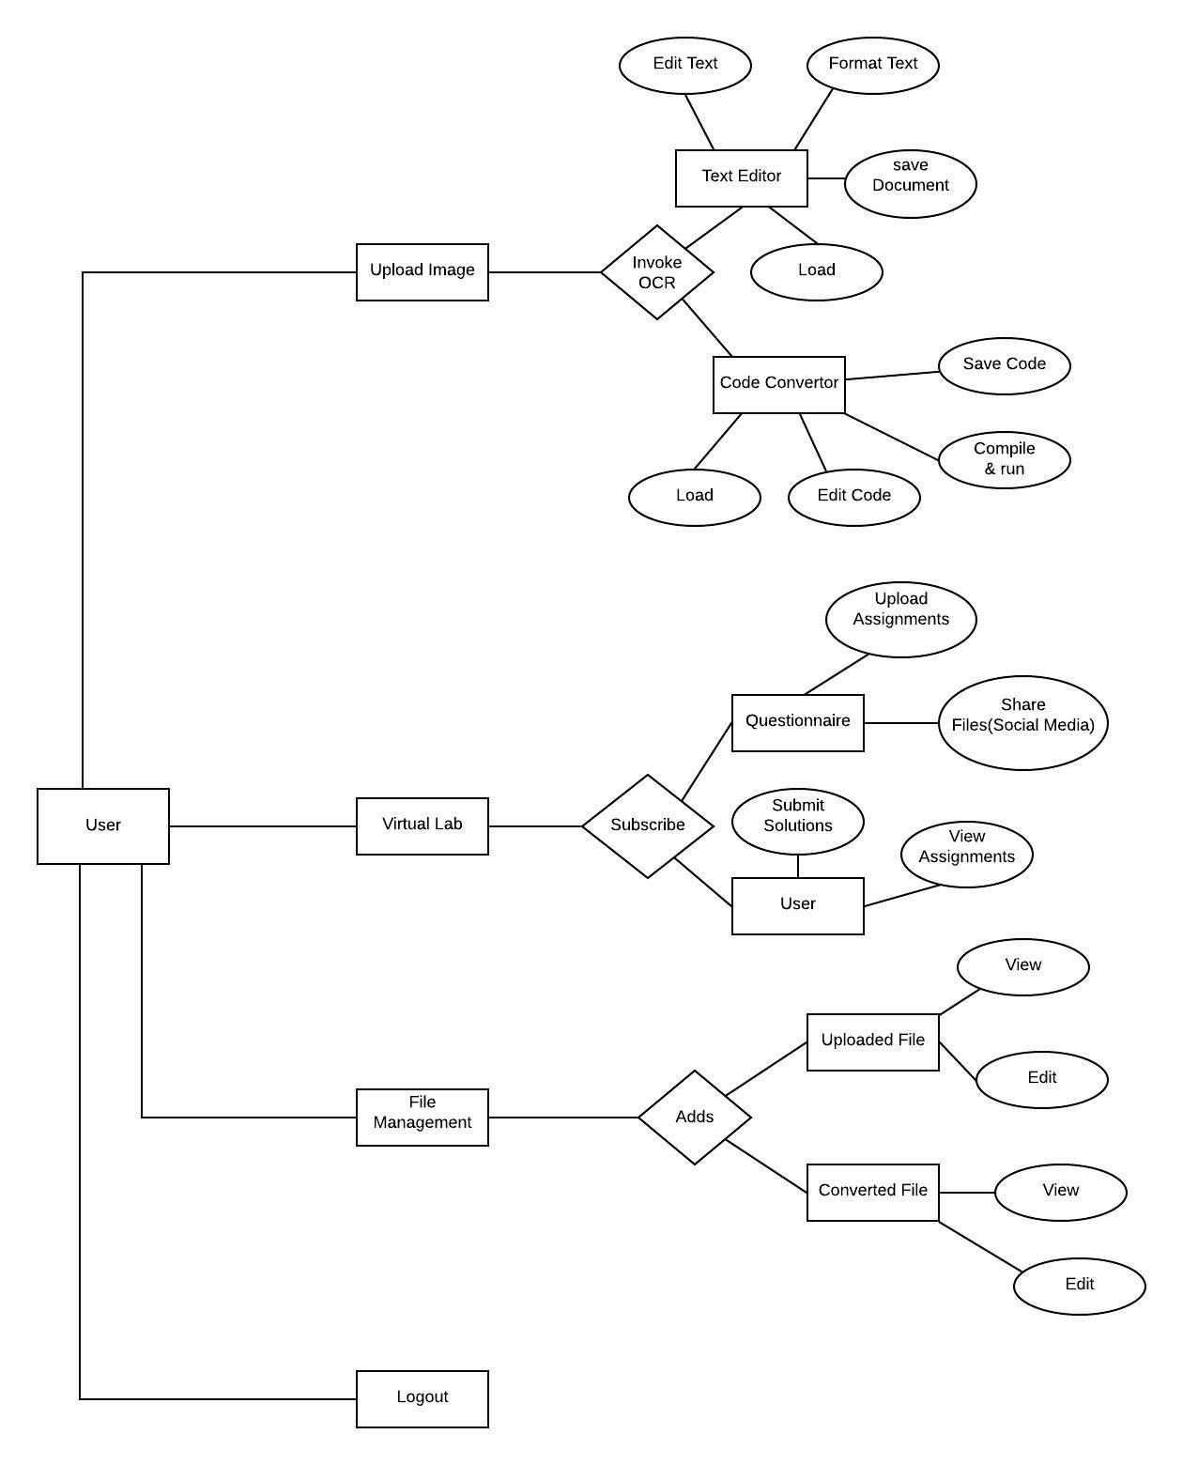

**Fig 9.1**

**Chapter-10**

**DATABASE DICTIONARY**

**Database designs** the process of producing a detailed data model of a database. This logical data model contains all the needed logical and physical design choices and physical storage parameters needed to generate a design in a Data Definition Language, which can then be used to create a database. A fully attributed data model contains detailed attributes for each entity. The term database design can be used to describe many different parts of the design of an overall database system. Principally, and most correctly, it can be thought of as the logical design of the base data structures used to store the data. In the relational model these are the tables and views. In an object database the entities and relationships map directly to object classes and named relationships. However, the term database design could also be used to apply to the overall process of designing, not just the base data structures, but also the forms and queries used as part of the overall database application within the database management system (DBMS).

**Database worddata**

**Table structure for table wp_cntctfrm_field**

|  |  |  |  |
| --- | --- | --- | --- |
| **Field** | **Type** | **Null** | **Default** |
| ***id*** | int(11) | No | NULL |
| name | char(100) | No | NULL |

**Table 10.1**

**Dumping data for table wp_cntctfrm_field**

|  |  |
| --- | --- |
| **id** | **name** |
| 1 | name |
| 2 | email |
| 3 | subject |
| 4 | message |
| 5 | address |
| 6 | phone |
| 7 | attachment |
| 8 | attachment_explanations |
| 9 | send_copy |
| 10 | sent_from |
| 11 | date_time |
| 12 | coming_from |
| 13 | user_agent |

**Table 10.2**

**Table structure for table wp_ex_mapping**

|  |  |  |  |
| --- | --- | --- | --- |
| **Field** | **Type** | **Null** | **Default** |
| ***regID*** | varchar(255) | No | NULL |
| testID | int(30) | No | NULL |
| userID | int(30) | No | NULL |
| date | Date | No | NULL |

|  |  |  |  |
| --- | --- | --- | --- |
|  |  |  |  |
|  |  |  |  |
|  |  |  |  |
|  |  |  |  |

**Table 10.3**

**Dumping data for table wp_ex_mapping**

|  |  |  |  |
| --- | --- | --- | --- |
| ***regID*** | **testID** | **userID** | **date** |
| REG-1015 | 1 | 1 | 2014-01-04 |
| REG-1020 | 4 | 1 | 2014-01-21 |
| REG-1029 | 1 | 1 | 2014-01-04 |
| REG-1035 | 5 | 1 | 2014-01-09 |
| REG-1121 | 4 | 1 | 2014-01-10 |
| REG-1127 | 4 | 1 | 2014-01-09 |
| REG-1128 | 1 | 1 | 2014-01-03 |
| REG-1129 | 1 | 1 | 2014-01-04 |
| REG-1142 | 4 | 1 | 2014-01-19 |
| REG-1182 | 4 | 1 | 2014-01-19 |
| REG-1208 | 5 | 1 | 2014-02-08 |
| REG-1212 | 1 | 1 | 2014-01-03 |

**Table 10.4**

**Table structure for table wp_ex_result**

|  |  |  |  |
| --- | --- | --- | --- |
| **Field** | **Type** | **Null** | **Default** |
| ***ID*** | int(30) | No | NULL |
| userID | int(30) | No | NULL |
| regID | varchar(255) | No | NULL |
| total | int(30) | No | NULL |
| gain | int(30) | No | NULL |
| wrong | int(30) | No | NULL |

**Table 10.5**

**Dumping data for table wp_ex_result**

|  |  |  |  |  |  |
| --- | --- | --- | --- | --- | --- |
| ***ID*** | **userID** | **regID** | **total** | **gain** | **wrong** |
| 153 | 1 | REG-7416 | 10 | 10 | 0 |
| 154 | 1 | REG-5222 | 10 | 8 | 1 |
| 155 | 1 | REG-8406 | 10 | 6 | 1 |
| 156 | 1 | REG-3528 | 10 | 6 | 1 |
| 157 | 1 | REG-9350 | 10 | 4 | 3 |
| 158 | 1 | REG-8583 | 10 | 2 | 2 |
| 159 | 1 | REG-3770 | 10 | 4 | 2 |
| 160 | 1 | REG-4665 | 10 | 4 | 3 |
| 161 | 1 | REG-5409 | 10 | 2 | 2 |
| 162 | 1 | REG-8625 | 10 | 0 | 5 |
| 163 | 1 | REG-8906 | 10 | 4 | 3 |
| 164 | 1 | REG-7723 | 10 | 4 | 3 |
| 165 | 1 | REG-8710 | 10 | 4 | 2 |
| 166 | 1 | REG-3635 | 10 | 4 | 3 |
| 167 | 1 | REG-9653 | 10 | 0 | 5 |
| 168 | 1 | REG-7271 | 10 | 4 | 3 |

**Table 10.6**

**Table structure for table wp_m_membership_levels**

|  |  |  |  |
| --- | --- | --- | --- |
| **Field** | **Type** | **Null** | **Default** |
| ***id*** | bigint(20) | No | NULL |
| level_title | varchar(250) | Yes | NULL |
| level_slug | varchar(250) | Yes | NULL |
| level_active | int(11) | Yes | NULL |
| level_count | bigint(20) | Yes | NULL |
|  |  |  |  |

**Table 10.7**

**Dumping data for table wp_m_membership_levels**

|  |  |  |  |  |
| --- | --- | --- | --- | --- |
| ***id*** | **level_title** | **level_slug** | **level_active** | **level_count** |
| 1 | user_paid_member | user_paid_member | 1 | 0 |
| 2 | paid ones | paid-ones | 1 | 0 |
| 3 | free users | free-users | 1 | 0 |
| 4 | Visitors | visitors | 1 | 0 |
| 5 | 3 Months | 3-months | 1 | 0 |
| 6 | 45 Days | 45-days | 1 | 0 |
| 7 | Visitors | visitors | 1 | 0 |

**Table 10.8**

**Table structure for table wp_m_subscriptions**

|  |  |  |  |
| --- | --- | --- | --- |
| **Field** | **Type** | **Null** | **Default** |
| ***Id*** | bigint(20) | No | NULL |
| sub_name | varchar(200) | Yes | NULL |
| sub_active | int(11) | Yes | NULL |
| sub_public | int(11) | Yes | NULL |
| sub_count | bigint(20) | Yes | NULL |
| sub_description | text | Yes | NULL |
| sub_pricetext | varchar(200) | Yes | NULL |

**Table 10.9**

**Dumping data for table wp_m_subscriptions**

|  |  |  |  |  |  |
| --- | --- | --- | --- | --- | --- |
| ***id*** | **sub_name** | **sub_active** | **sub_count** | **sub_description** | **sub_pricetext** |
| 1 | Annual Plan | 1 | 1 | 0 | Only @19.00$ |
| 4 | 3 Months | 1 | 1 | 0 | Only @10.00$ |
| 2 | 6 Month | 1 | 1 | 0 | Only @14.00$ |
| 3 | free users | 1 | 0 | 0 | NULL |
| 5 | 45 Days | 1 | 1 | 0 | Only @6.50$ |

**Table 10.10**

**Table structure for table wp_users**

|  |  |  |  |
| --- | --- | --- | --- |
| **Field** | **Type** | **Null** | **Default** |
| ***ID*** | bigint(20) | No | NULL |
| user_login | varchar(60) | No | NULL |
| user_pass | varchar(64) | No | NULL |
| user_nicename | varchar(50) | No | NULL |
| user_email | varchar(100) | No | NULL |
| user_url | varchar(100) | No | NULL |
| user_registered | datetime | No | NULL |
| user_activation_key | varchar(60) | No | NULL |
| user_status | int(11) | No | NULL |
| display_name | varchar(250) | No | NULL |

**Table 10.11**

**Dumping data for table wp_users**

|  |  |  |  |  |  |  |  |  |  |
| --- | --- | --- | --- | --- | --- | --- | --- | --- | --- |
| ***ID*** | **user_login** | **user_pass** | **user_nicename** | **user_email** | **user_url** | **user_registered** | **user_activation_key** | **user_status** | **display_name** |
| 1 | admin | $P$BUUHndVuE0 | admin | abbasgabru52@gmail.com |  | 2013-12-25 05:37:04 | $P$BQViL/zNCxWuF | 0 | admin |
| 2 | kammu | $P$B9p5F5zl3LZ1 | kammu | support@vyasinfosys.com |  | 2013-12-30 07:04:19 |  | 0 | Kamlesh Vyas |
| 9 | ssss | $P$Be5I2yulmYm0 | ssss | abbas@gmail.com |  | 2014-01-14 12:06:22 |  | 0 | Ssss |
| 11 | ghhgd | $P$BcE/k7bb3IjcZ0 | ghhgd | jhkjh@gmail.com |  | 2014-01-14 12:14:50 |  | 0 | ghhgd |
| 12 | cbvcbv | $P$Brablb0lTq2Ao0 | cbvcbv | dsft@gmail.com |  | 2014-01-14 12:21:58 |  | 0 | cbvcbv |
| 13 | jdhbkd | $P$BP7nflNTcgC91 | jdhbkd | sdjhhj@gmail.com |  | 2014-01-16 06:44:11 |  | 0 | assss ssss |

**Table 10.12**

**Chapter-11**

**INPUT AND OUTPUT SCREEN DESIGN(SNAPSHOTS)USER**

**11.1 HOME PAGE**



**Fig 11.1 : Home Page**

**11.2 START TEST PAGE**

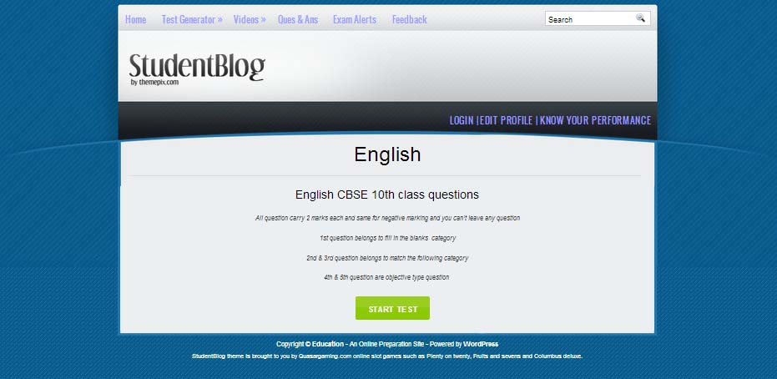

**Fig 11.2: START TEST PAGE**

**11.3 TEST PAGE**

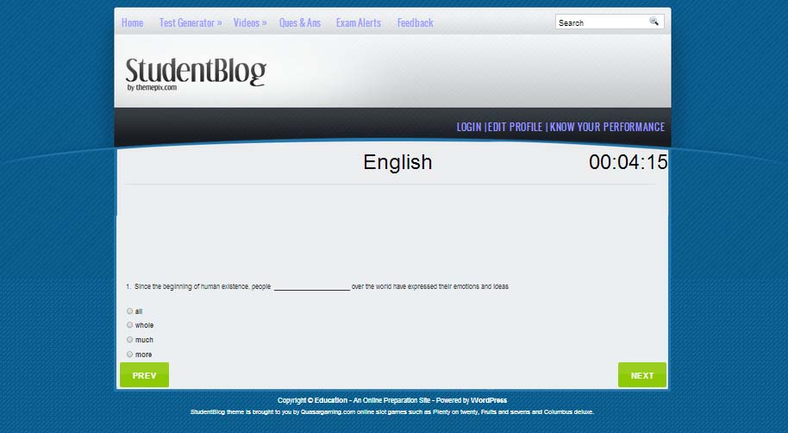

**Fig 11.3: TEST PAGE**

**11.4 TEST RESULT PAGE**

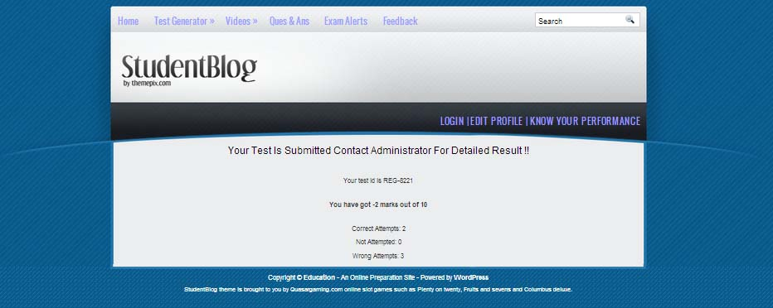

**Fig 11.4: TEST RESULT PAGE**

**11.5 VIDEOS PAGE**

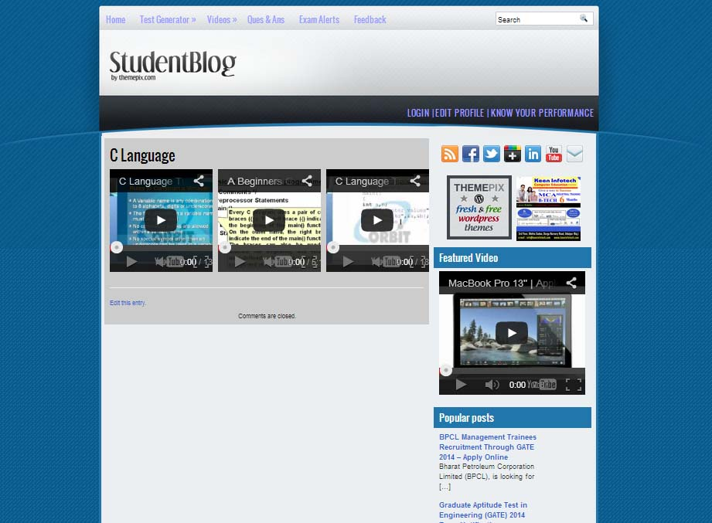

**Fig 11.5: VIDEOS PAGE**

**11.6 TOTAL QUESTIONS PAGE**

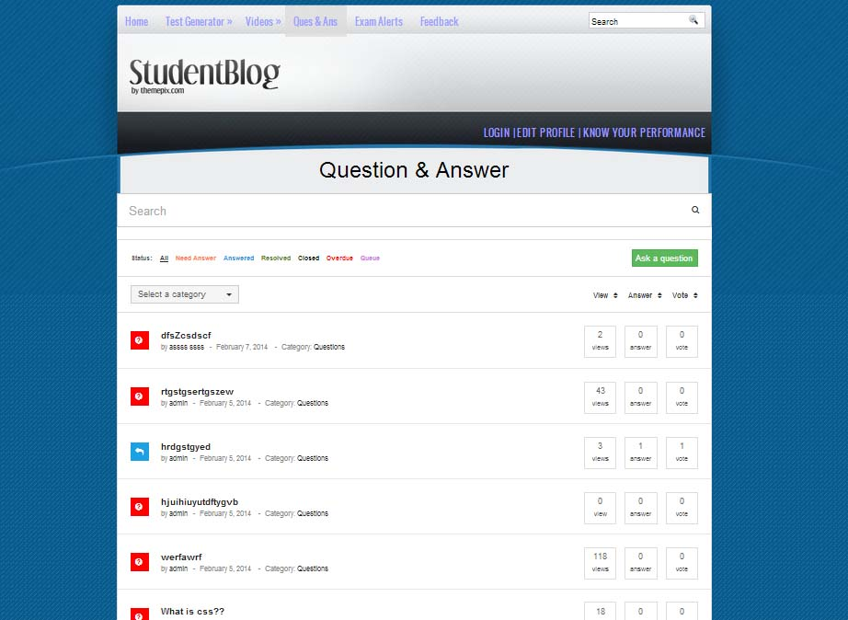

**Fig 11.6: TOTAL QUESTIONS PAGE**

**11.7 ASK QUESTION PAGE**

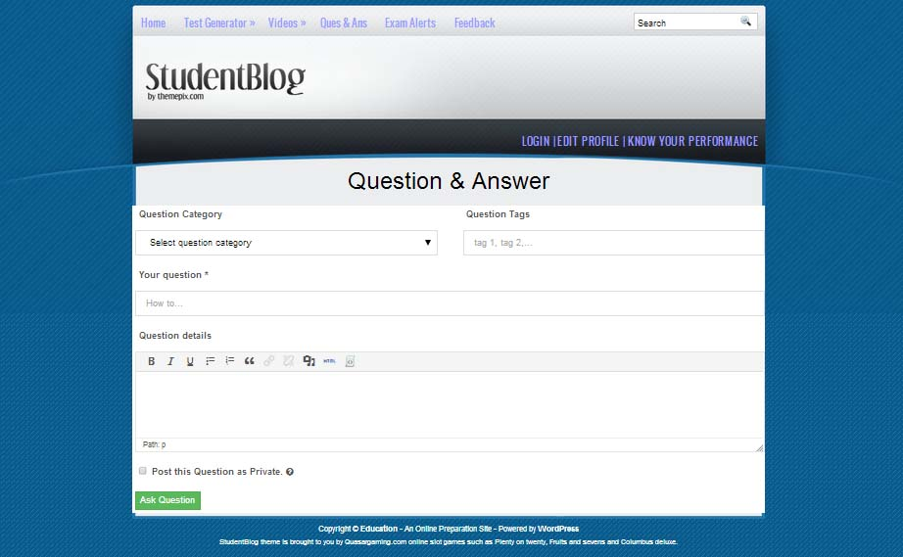

**Fig 11.7: ASK QUESTION PAGE**

**11.8 ADD ANSWER PAGE**

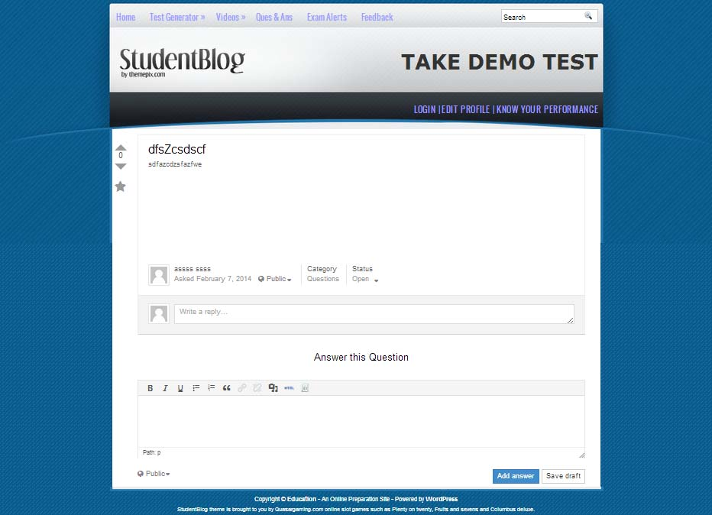

**Fig 11.8: ADD ANSWER PAGE**

**11.9 EXAM ALERTS PAGE**

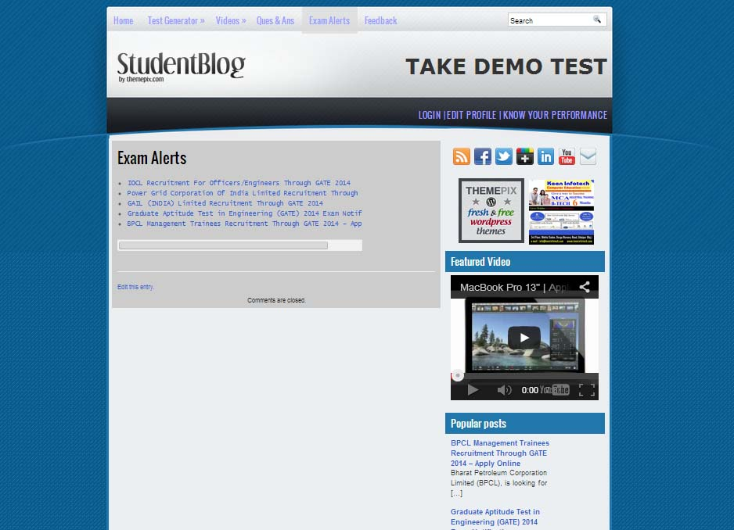

**Fig 11.9: EXAM ALERTS PAGE**

**11.10 FEEDBACK FORM PAGE**

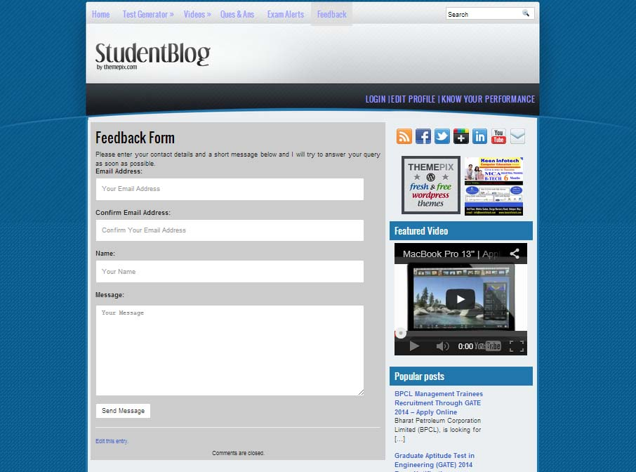

**Fig 11.10: FEEDBACK FORM PAGE**

**11.11 LOGIN PAGE**

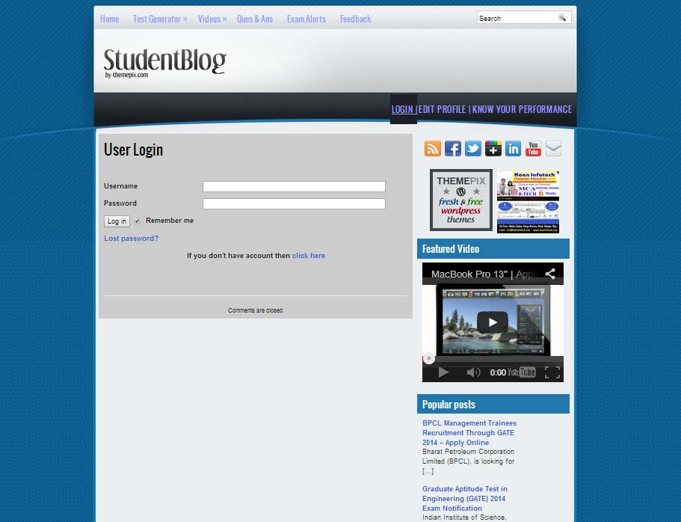

**Fig 11.11: LOGIN PAGE**

**11.12 EDIT PROFILE PAGE**

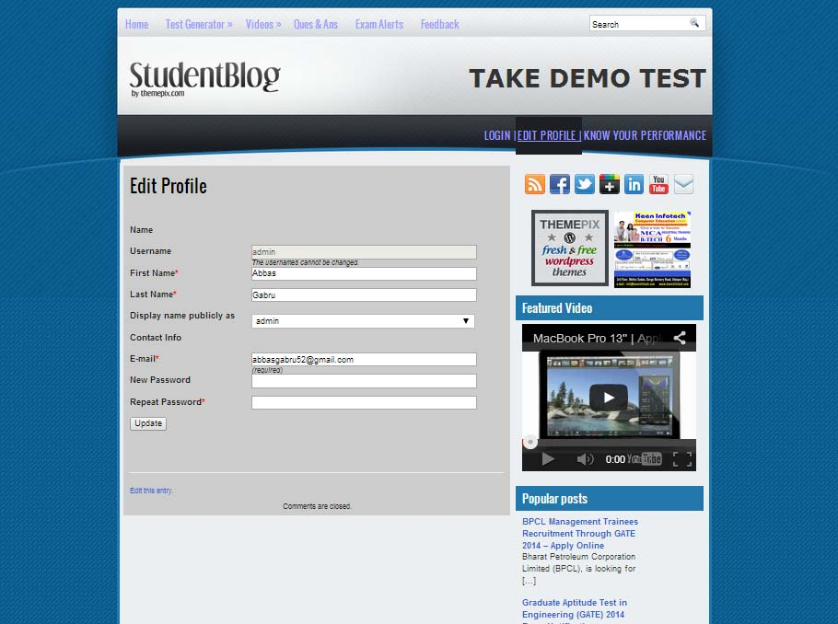

**Fig 11.12: EDIT PROFILE PAGE**

**11.13 MEMBERSHIP SIGNUP PAGE**

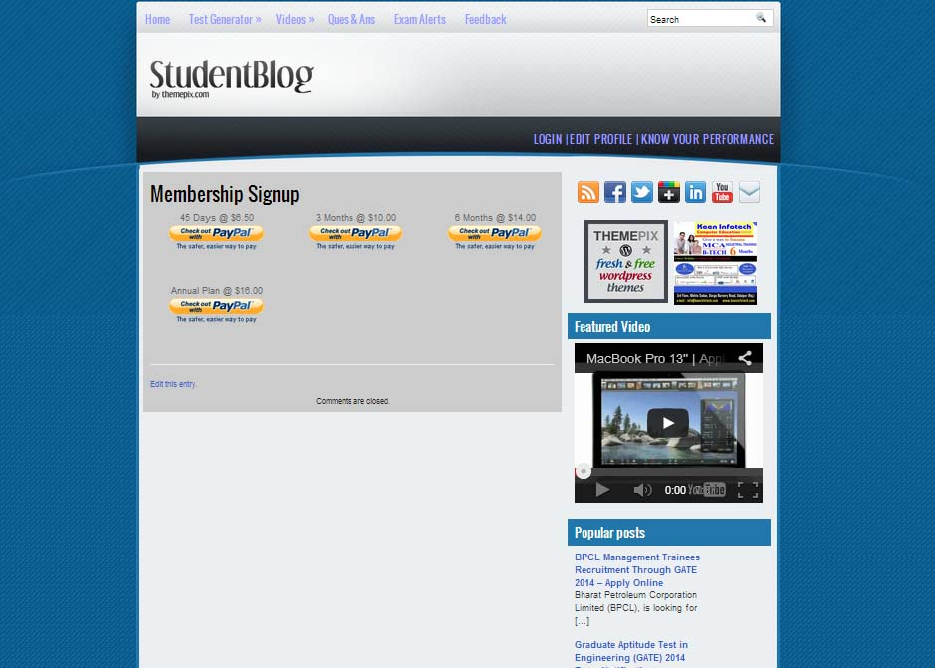

**Fig 11.13: MEMBERSHIP SIGNUP PAGE**

**ADMIN**

**11.14 MAIN DASHBOARD**

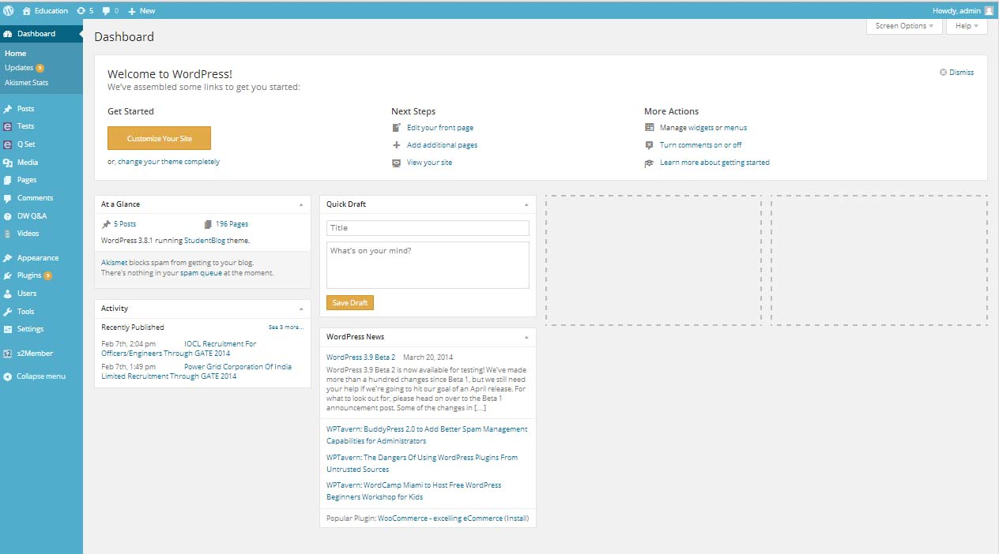

**Fig 11.14: MAIN DASHBOARD**

**11.15 ADD QUESTION PAGE**

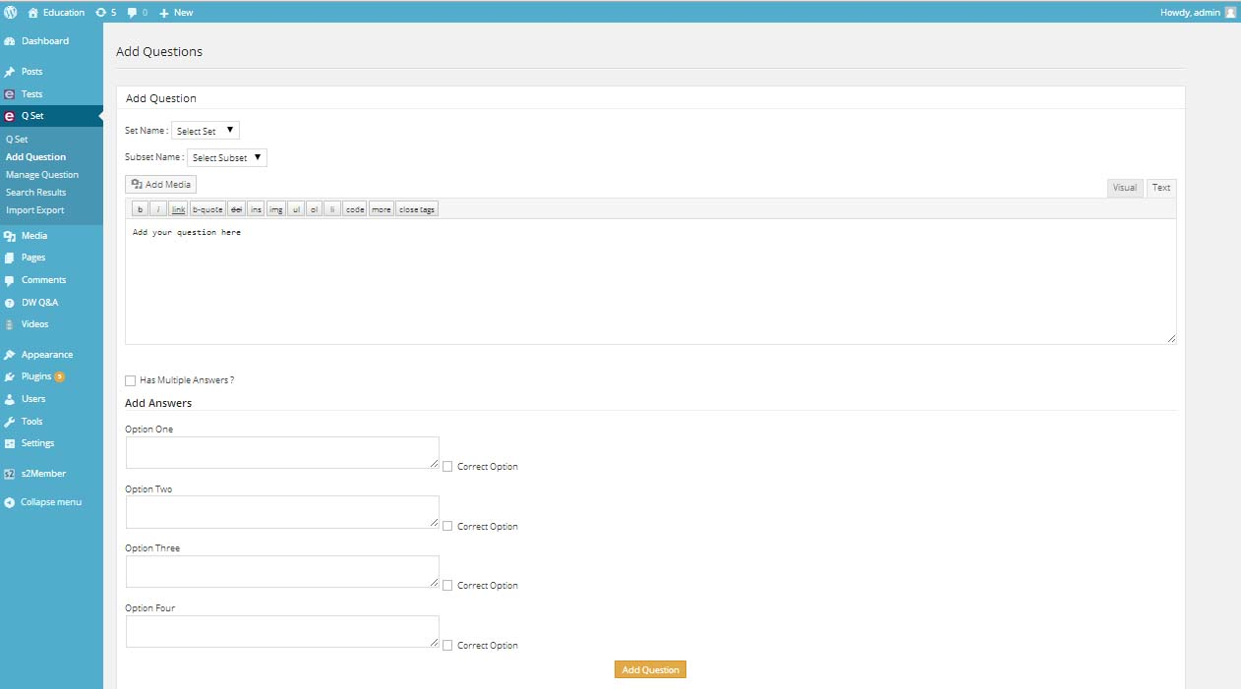

**Fig 11.15: ADD QUESTION PAGE**

**11.16 USER MANAGEMENT**

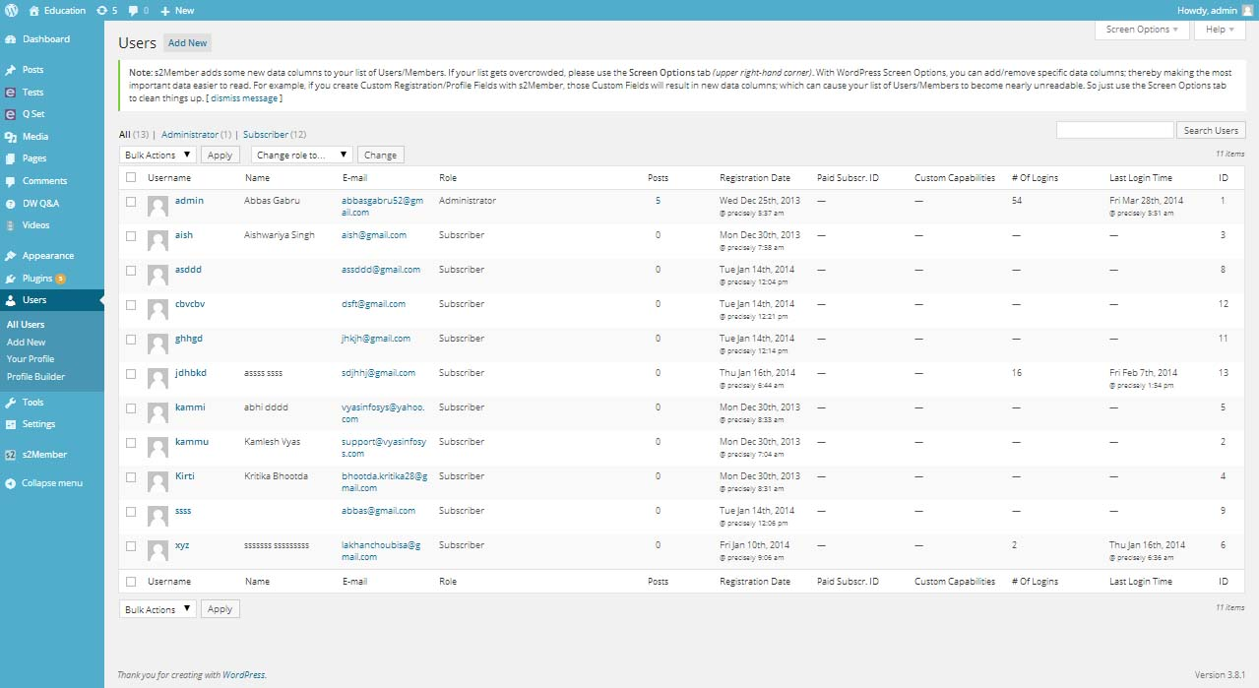

**Fig 11.16: USER MANAGEMENT**

**Chapter-12**

**METHODOLOGY USED FOR TESTING DFD**

**12.1 INTRODUCTION.**

**What is ‘Software Testing’?**

Testing involves operation of a system or application under controlled conditions and evaluating the results. The controlled conditions should include both normal and abnormal conditions. Testing should intentionally attempt to make things go wrong to determine if things happen when they don’t happen when they should. It is oriented to ‘detection’.

**The need for Testing:**

No matter how good a programmer is, no application will ever be one hundred percent correct. Testing was important to us in order to ensure that the application works as efficient as possible and conforms to the needs of the system.

Testing was carried out throughout the development of the application, not just the application has been developed, as at this stage it took a great deal of effort to fix any bugs or design problems that were occurred.

**12.2 TESTING STRATEGY**

When our application was configured and customized in the system, the test was observed that this configuration or customization does not cause any improper processing or violation. The following care was taken when the application was developed at the local machine.

**12.3 TESTING METHODS**

**While Box Testing**

Also known as glass box, structural, clear box and open box testing. A software testing technique where by explicit knowledge of the internal workings of the item being tested are used to select the test data. Unlike black box testing, white box testing uses specific knowledge of programming code to examine outputs. The test is accurate only if the tester knows what the program is supposed to do, it means that he must be completely aware that for particular input a particular output must be obtained.The main benefit of this type of testing is Tester can see if the program diverges from its intended goal. This test concentrates on the examination of the coze rather than the specification.

**Black Box Testing**

Black-box and white-box are test design methods. Black-box test design treats the system as a "black-box", so it doesn't explicitly use knowledge of the internal structure. Black-box test design is usually described as focusing on testing functional requirements. Also know as behavioral, functional, opaque-box, and closed-box.

Black Box Testing was helpful us to find error such as:

* Interface error.
* Incorrect or missing functions.
* Errors in data structures or external database access.
* Performance Errors.
* Initialization and termination errors.

We have also done **Boundary value analysis** by applying different size of digits.The number field can only take 6 or 10 digit number.

We also check special cases like:

* User can not send same number for more than five times.
* User can not send Blank message.
* User can send empty file to other user.
* User‘s message other than query message send to only selected no.
  + - System can handle up to 1000 user call at a same time.
    - System can send sms to 100 user number at a same time.
    - Max 15 number of user can do group chat.

**Unit Testing**

Unit testing is a method of testing the correctness of a particular module of source code. The idea is to write test cases for every non-trivial function or method in the module so that each test case is separate from the others if possible. The developers mostly do this type of testing. In this method of testing we test all individual components to ensure that they operate correctly. Each component is tested independently without other system components.

**Integration Testing**

It is the phase of software testing in which individual software modules we are combined and tested as a group. It follows unit testing and precedes system testing.

The purpose of Integration testing is to verify functional, performance and reliability requirements placed on major design items.

It takes as its input modules that have been checked out by unit testing, groups them in larger aggregates, applies tests defined in an Integration test plan to those aggregates, and delivers as its output the integrated system ready for system testing.

**Chapter-13**

**USER/OPERATIONAL MANUAL**

|  |  |  |
| --- | --- | --- |
| **TEST REPORT WITH TEST DATA** | | |
| **Project Name : ONLINE QUIZ SITE** | | |
| **S no.** | **Testing Parameter** | **Observations** |
| A. | INTERFACE TESTING  1) User-friendliness  2) Consistent menus | OK  NA |
| B. | CONTROL FLOW TESTING  1) IF-THEN-ELSE  2) DO WHILE  3) CASE-SWITCH | OK  OK  NA |
| C. | VALIDATION TESTING  1) Check for improper or inconsistent typing  2) Check for erroneous initialization or default values  3) Check for incorrect variable names  4) Check for inconsistent Data Types  5) Check for relational/arithmetic operators | OK  OK  OK  OK  OK |
| D. | DATA INTEGRITY/SECURITY TESTING  1) Data Insertion/ Deletion/ Updating  2) Boundary condition (Underflow, Overflow Exception)  3) Check for unauthorized access of data  4) Check for data availability | OK  OK  OK  OK |
| E. | EFFICIENCY TESTING  1) Throughput of the system  2) Response time of the system  3) Online disk storage required by the system  4) Primary memory required by the system | OK  OK  OK  OK |
| F. | ERROR HANDLING ROUTINES  1) Error description are intelligent/ understandable  2) Error recovery is smooth. | OK  OK |

**Chapter-14**

**FUTURE ENHANCEMENT**

This solution will provide assistance in creating, conducting and evaluating examinations. Large organizations will be able to have a centralized database of questions, from which the tests will be prepared. Internet will be used as a media for disseminating and conducting tests, thus maintaining a uniform pattern for all the examinees throughout the organization.

The task of maintaining the record of scores and the tests for which a particular candidate has appeared will be done by the portal. The progress reports can be printed at any point of time by just providing the necessary details of a candidate. The solution can also be used by faculty members to create question papers. They can provide a question bank consisting of questions of varied difficulty levels. Numerous sets of distinct question papers can then be printed, consisting of all type of questions in equal proportion. The same can be put to use in corporate organizations and universities or colleges.

For schools, colleges or universities managing the examination have never been easy. Now school teachers and college/university professors can manage question papers very easily.

This system aims to be a powerful tool for eLearning and online education. You can create quiz, question bank, certification examination questions in any language. Useful for school, college, university, teachers and professors for managing question papers and examinations. Recruiting agencies or companies can use it for candidate’s skill evaluation by conducting online test. It is very useful for parents in the academic development of kids to improve their educational skills.

The system is consisting of a web server with a database facility. This server is configured with proper security measures. Clients (candidates) can connect through the internet with a web browser (e.g.: Internet Explorer, Mozilla Firefox etc) to the server and take the exam. Examiners too can connect to the server through the internet or through the intranet for setting up papers and to do other related tasks.

**Chapter-15**

**CONCLUSION**

The development of software or website includes so many people like user system developer, user of system and the management. It is important to identify the system requirements by properly collecting required data to interact with supplier and customer of the system. Proper design builds upon this foundation to give a blue print, which is actually implemented by the developers.

On realizing the importance of systematic documentation all the processes are implemented using a software engineering approach. Working in a live environment enables one to appreciate the intricacies involved in the System Development Life Cycle (SDLC).

We have gained a lot of practical knowledge from this project, which we think, shall make us stand in a good state in the future.

**Chapter-16**

**REFERENCES**

1. Shariefuddin Pirzada, Ashay Dharwadker, “Applications of Graph Theory [Journal of the Korean Society for Industrial and Applied Mathematics”, vol.-11, no.-4, 2007](http://mathnet.kaist.ac.kr/mathnet/kms_content.php?no=379610)
2. Geir Agnarsson, Raymond Greenlaw, “Graph Theory, Modeling, Applications and Algorithms”,*ISBN 978-81-317-1728-8*, Pearson Education Asia Pvt. Ltd., 2008
3. L. Caccetta and K. Vijayan, “Applications of Graph Theory”,Fourteenth Australasian Conference on Combinatorial Mathematics and Computing, vol.-23, pp. 21-77, 1987
4. F. S. Roberts, “Graph Theory and its Applications to the Problems of Society”, CBMS-NSF Monograph 29, SIAM Publications, Philadelphia, 1978
5. C.Vasudev, “Graph Theory with Applications to Engineering and Computer Science”,*ISBN 0-224- 1737-X*, New Age International Pvt. Limited, New Delhi, 2006
6. B. Andrasfai, “Introductory Graph Theory”,Institute of Physics, 1978
7. J. Bang-Jensen and G. Gutin, “Digraphs: Theory, Algorithms and Applications”,Springer-Verlag 2002
8. Lois E. Reed, ”Performing a Literature Review”, Systems Engineering Division,Naval Air Warfare Center Weapons Division, China LakeCA, 93555-6100